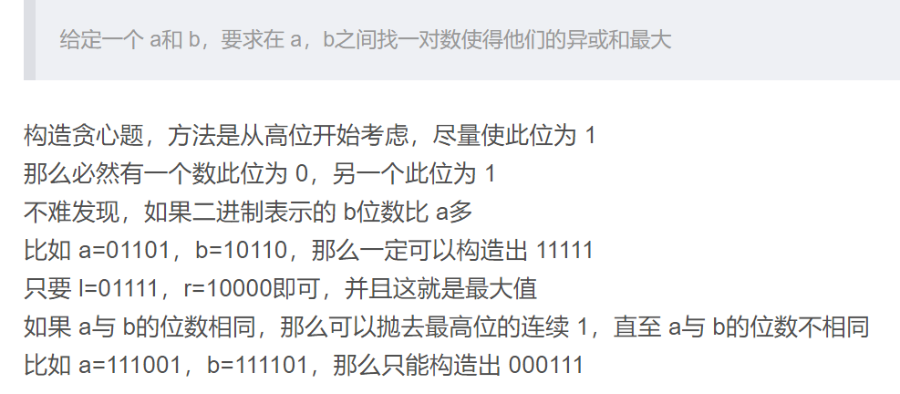

#include<cstdio>

#include<set>

#include<cstring>

#include<bits/stdc++.h>

#include<map>

#include<iostream>

#define fre freopen("input.txt","r",stdin);

using namespace std;

typedef long long ll;

int main()

{

// fre;

ll a,b;

cin>>a>>b;

if(a==b)

{

puts("0");

return 0;

}

int st=max(64-__builtin_clzll(a),64-__builtin_clzll(b));

//返回前导0的个数

//st是最大的位数

for(int i=st; i>=0; i--)

{

if((a&(1LL<<i))!=(b&(1LL<<i)))

{

ll ans=(1LL<<(i+1))-1;

cout<<ans<<endl;

return 0;

}

}

return 0;

}

按照这个思想，其实这样写就可以

#include <iostream>

#define ll long long

using namespace std;

int main()

{

ll a, b, c, ans = 1;

cin >> a >> b;

c = a ^ b;

while(ans <= c)

ans <<= 1;

cout << ans - 1 << endl;

}